**State Diagram:**

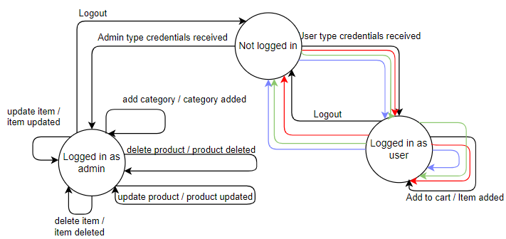

Red lines: state coverage

Green lines: event coverage

Blue lines: transition coverage

|  |  |  |  |
| --- | --- | --- | --- |
| **Current State** | **Event** | **Action** | **Next State** |
| Not logged in | User type credentials received | ____ | Logged in as user |
| Logged in as user | Add to cart | Item added | Logged in as user |
| Logged in as user | Logout | ------- | Not logged in |
| Not logged in | Wrong credentials received | Input wrong credentials | Not logged in |

**Faults covered in state diagram:**

1. When we enter admin type credentials, system moves towards logged in as user state instead of logged in as admin.
2. Due to above mentioned fault, the missing state is logged in as admin.
3. Missing events are updating item, delete item, update product, delete product and category.
4. Missing transitions are “Not logged in” to “Logged in as admin” and “logged in as admin” to “Not logged in”.